**FRAUD DETECTION IN FASTAG PAYMENTS**

**A Project Report submitted to Chaitanya Deemed to be University in partial fulfilment of minimum academic requirements for IV Year II Semester**

**BACHELOR OF TECHNOLOGY**

**COMPUTER SCIENCE AND ENGINEERING**

**Submitted By**

**A. RAKESH (221202004)**

**M. PUJITHA (221202005)**

**B. ROHITH (221202006)**

**M. KARTHIK (221202007)**

**V. VYSHNAVI (221202015)**

**Under the guidance of**

**Dr. E SAIKIRAN**

**Assoc. Professor in CSE**

**DEPARTMENT OF COMPUTER SCIENCE AND ENGINEERING**

**FACULTY OF ENGINEERING**

**CHAITANYA DEEMED TO BE UNIVERSITY**

**HANAMKONDA, WARANGAL – 506001**

**(2024-2025)**

**FACULTY OF ENGINEERING**

**HANAMKONDA, WARANGAL – 506001**

**DEPARTMENT OF COMPUTER SCIENCE AND ENGINEERING**

**CERTIFICATE**

This is to certify that the major project report entitled “**FRAUD DETECTION IN FASTAG PAYMENTS**” is being submitted by A. RAKESH (221202004), M.PUJITHA (221202005), B.ROHITH (221202006), M.KARTHIK (221202007), V.VYSHNAVI (221202015), in the partial fulfilment of the requirements for the award of the degree of **Bachelor of Technology in Computer Science and Engineering** at the **Chaitanya deemed to be University** during the academic year 2024 – 2025.

Name and Signature of the Guide Name and Signature of the HOD

(**Dr. E. SAIKIRAN, Assoc. Prof in CSE) (Dr. E. Aravind, Assoc. Prof)**

**Dean, Faculty of Engineering**

**(Prof. G. SHANKARLINGAM)**

**Signature of the External examiner with Date**

**ACKNOWLEDGEMENT**

The success accomplished in this project would not have been possible, by timely help and guidance rendered by many people, we wish to express our sincere and heartfelt gratitude to all those who have helped and guided us for the completion of the project.

We sincerely extend thanks to our project guide **Dr. E Saikiran** Department of Computer Science and Engineering for giving us moral support, kind attention and valuable guidance to us throughout this training work. We extent our heartfelt thanks to **Dr. E. Aravind**, Head, the Department of Computer Science and Engineering for his encouragement during the progress of this major project work. We would like to express our deep sense of gratitude to **Prof. G. SHANKARLINGAM**, Dean, Faculty of engineering, for providing the required facilities in the college campus.

We would also thank all the staff of department of electronics and communication engineering who has helped us directly or indirectly for the successful completion of the project. Finally, we express our sincere thanks & gratitude to our family members & friends for their constant encouragement and moral support, which made the project successful.

A. RAKESH (221202004)

M. PUJITHA (221202005)

B. ROHITH (221202006)

M. KARTHIK (221202007)

V. VYSHNAVI (221202015)

**DECLARATION**

We here submit that the project report entitled “**FRAUD DETECTION IN FASTAG PAYMENTS**” is an original work done at the **Faculty of Engineering, Hanamkonda** under the valuable guidance of **Dr. E**.**SAIKIRAN**, **Department of Computer Science and Engineering**, in partial fulfilment of the requirement for the award of the degree of Bachelor of Technology in Computer Science and Engineering. We hereby declare that this project report bears no resemblance to any other reports submitted at the Faculty of Engineering, Chaitanya deemed to be a University for the award of the degree.

A. RAKESH (221202004)

M. PUJITHA (221202005)

B. ROHITH (221202006)

M. KARTHIK (221202007)

V. VYSHNAVI (221202015)

**ABSTRACT**

The rapid adoption of FASTAG for electronic toll collection in India, fraudulent activities such as unauthorized transactions, duplicate FASTAG usage, and GPS spoofing have become growing concerns. Traditional rule-based fraud detection methods struggle to keep pace with evolving fraud tactics. To address this challenge, we propose a Machine Learning (ML)-based Fraud Detection System that leverages historical transaction data, anomaly detection techniques, and predictive analytics to identify and mitigate fraudulent FASTAG transactions in real-time.

Our system employs supervised learning models like Random Forest for fraud classification, along with unsupervised anomaly detection techniques such as Isolation Forest and Auto encoders to detect suspicious patterns. Key features analysed include transaction time, vehicle category, toll booth location, and user behaviour patterns. Additionally, real-time processing is enabled using streaming analytics frameworks to ensure instant fraud detection and mitigation.

By integrating ML models with FASTAG transaction systems, this approach enhances fraud detection accuracy, reduces financial losses, and ensures a more secure and efficient toll collection process. The proposed solution outperforms traditional rule-based systems by dynamically adapting to new fraud patterns, making it a scalable and effective solution for digital tolling infrastructures.

**TABLE OF CONTENTS**

**CONTENTS Page No**

**CHAPTER 1 INTRODUCTION 10**

1.1 Introduction 10

1.2 Overview of FASTag 11

1.3 Challenges in Conventional Tolling 12

1.4 History of FASTag Timeline 12

1.5 FASTag 13

1.6 RFID Working Technology System 15

1.7 Goal 16

1.8 Objectives 16

1.9 Methodology 17

1.10 Roles and Responsibilities 21

1.11 Contribution of Project 22

1.12 Report 22

**CHAPTER 2 SYSTEM STUDY 23**

2.1 Existing system 23

2.2 Proposed system 24

**CHAPTER 3 REQUIREMENT ENGINEERING 26**

3.1 Functional requirements 26

3.2 Non-Functional requirements 27

**CHAPTER 4 ANALYSIS AND DESIGN 28**

4.1 Use case diagram 28

4.2 Sequence diagram 29

4.3 Activity diagram 30

4.4 System architecture 31

**CHAPTER 5 CONSTRUCTION 32**

5.1 System Requirements 32

5.1.1 Software requirements 32

5.1.2 Hardware requirements 32

**CHAPTER 6 IMPLEMENTATION 33**

6.1 Project Structure 33

6.2Project Modules and Description 34

6.3 Sample Code 37

6.4 Screenshots 41

6.5 Testing 45

**CHAPTER 7 EXPERIMENTS AND CONCLUSION 47**

7.1 Experiments and Results 47

7.2 Conclusion 49

**CHAPTER 8 REFERENCES 51**

**LIST OF FIGURES**

**CONTENTS Page no.**

Fig 1.1 FASTag affixed to the car’s wind shield 14

Fig 1.2 RFID System 15

Fig 4.1 Use case diagram 28

Fig 4.2 Sequence diagram 29

Fig 4.3 Activity diagram 30

Fig 4.4 System architecture 31

Fig 6.1 Website Interface 41

Fig 6.2 CSV Prediction using Random Forest 41

Fig 6.3 Logistic regression model performance 42

Fig 6.4 Comparison of model accuracies 42

Fig 6.5 Real time Statistics 43

Fig 6.6 Real time statistics volume vs value 43

Fig 6.7 Fraud Statistics 44

Fig 6.8 Fraud Indicator Statistics 44

Fig 7.1 Percentage of Fraud vs Not Fraud 48

Fig 7.2 Comparison of Accuracy scores 48

Fig 7.3 Statistics of Real-Time data 48

**LIST OF TABLES**

Table 1.1 Roles and Responsibilities 21

Table 7.1 Model Accuracies 47

**FRAUD DETECTION IN FASTAG PAYMENTS USING MACHINE LEARNING**

**CHAPTER-1**

**INTRODUCTION TO FASTAG PAYMENTS**

* + 1. **Introduction**

These days, most toll payments on highways are facilitated through FASTag, a prepaid RFID-based system that automatically deducts toll charges as vehicles pass through toll plazas. While this system significantly reduces congestion and improves efficiency, it also introduces new challenges related to payment fraud and misuse of the system. Fraudulent activities such as tag cloning, unauthorized tag use, and incorrect deductions have raised concerns regarding the security and transparency of the toll collection process.

To address these issues, a smart and cost-effective technique known as Machine Learning-based Fraud Detection in FASTag Payments is proposed. This solution aims to enhance the integrity and reliability of the FASTag system by leveraging advanced data analysis and real-time anomaly detection algorithms.

Our goal is to build an intelligent fraud detection system that monitors FASTag transactions in real-time, identifies suspicious activities, and flags potential fraud cases automatically. The system will be trained on historical transaction data to learn typical user behaviour patterns and use this knowledge to detect anomalies such as:

* Transactions at improbable locations within a short time span (indicating tag cloning)
* Repeated payments for the same vehicle within a short duration
* Mismatches between vehicle class and toll amount
* Unusual usage patterns or high-frequency tag activity

The system integrates with existing toll collection infrastructure and employs a web-based dashboard for authorities to review flagged transactions. Additionally, users will be notified via SMS or mobile notifications in case of suspicious deductions, allowing for quicker dispute resolution.

The Smart FASTag Fraud Detection System ensures a secure and trustworthy toll collection environment, benefiting both users and toll operators by reducing revenue leakage and enhancing user confidence. The future scope includes integration with facial recognition, GPS tracking, and blockchain technology to further strengthen security, improve audit trails, and provide end-to-end transparency in digital toll payments.

* + 1. **Overview of FASTag and India's Highway Infrastructure**

FASTag, a cashless option for crossing toll gates on National Highways, was launched by the National Highways Authority of India (NHAI). FASTag is an RFID-enabled sticker that is placed on the windshields of vehicles. Toll gates use sensors that read the FASTag and immediately subtract the toll due.

The FASTag is a prepaid device that drivers can reload online with any amount they want. FASTags are installed on all new vehicles by default. FASTag-enabled vehicles have their own dedicated lanes at toll plazas, enabling a faster and smoother transit experience. These tags are issued on behalf of the NHAI by banks and other authorized financial institutions.

A toll tax is applicable when traveling on specific state or national highways, commonly known as toll roads. The funds collected through these tolls are reinvested into road maintenance and infrastructure development, ensuring safe and comfortable travel for all road users.

* + 1. **Challenges in Conventional Tolling**

• Due to the limited number of toll booths, the toll collecting process is slow.

• The slow toll collection process at the toll booths results in a minimum of 10 minutes of average waiting time each car.

• Fuel wastage as a result oflong lines at toll booths.

• Toll plaza accidents caused by cars abruptly changing lanes for speedier clearance.

• Time wasted at booths has a negative influence on the transportation industry as well as the entire economy. According to a 2016 study by IIM Calcutta, the country loses about Rs 40,000 crore per year owing to transportation delays. The study also found that the delays resulted in gasoline use

* + 1. **History Of FASTag Timeline**

From January 15, 2020, FASTag will be required for all cars, both private and commercial. According to figures issued by the National Payments Corporation of India on January 1, 2020, nearly 6.4 crore FASTag transactions worth Rs.1,256 crore was processed in December, compared to 3.4 crore transactions worth Rs.774 crore in November. In December, Paytm Payments Bank issued almost 40% of all FASTags. The government is currently putting in place the appropriate measures to promote it. The technology was first used as a test project on the Golden Quadrilateral between Ahmedabad and Mumbai in 2014.

• On November 4, 2014, the system became live on the Quadrilateral's Delhi-Mumbai leg.

• In July 2015, toll plazas along the Golden Quadrilateral's Chennai-Bangalore section began accepting FASTag payments.

• By April 2016, FASTag had been installed in 247 toll plazas on national highways across India, accounting for 70% of all toll plazas at the time.

• As of November 23, 2016, 347 fee plazas on national highways around the country accepted FASTag payments, out of a total of 366.

• On October 1, 2017, the NHAI opened a FASTag lane in each of its 370 toll plazas.

• On November 8, 2017, it was announced that FASTag would be required on all new vehicles sold in India after December 2017.

• FASTag is now connected to 600+ toll plazas. Many more are waiting to connect in the near future.

* + 1. **FASTag**

FASTag is a simple reloadable tag that allows for toll charges to be deducted automatically without the need to stop at toll plazas to pay. This tag is attached to the vehicle's windscreen and uses RFID technology. Set built as a test experiment on a segment of the Golden Gate Bridge, 2019 IJRAR Volume 6, Issue 2 www.ijrar.org IJRAR Volume 6, Issue 2 IJRAR Volume 6, Issue 2 IJRAR Volume 6, Issue 2 IJRAR Volume 6, Issue 2 (E-ISSN 2348-1269, P-ISSN 2349-5138; E-ISSN 2348-1269, P-ISSN 2348-1269, P-ISSN 2348-1269 www.ijrar.org International Journal of Research and Analytical Reviews (IJRAR) IJRAR1ANP004 International Journal of Research and Analytical Reviews (IJRAR) IJRAR1ANP004 International Journal of Research and Analytical Reviews (IJRAR) On November 4, 2014, the system was launched on the Delhi-Mumbai leg of the Quadrilateral, which runs between Ahmedabad and Mumbai. FASTag is currently in use at more than 240 toll plazas around the country. After recharging their FASTag accounts, users can drive their vehicles through the FASTag lanes at toll plazas, and the toll amount will be automatically debited from their accounts. After December 1, 2017, the government made it required for all vehicles manufactured or sold after that date to have a FASTag.

**Working:-**

A unique RFID tag affixed to the vehicle's wind shield allows toll payments to be made straight from the bank or prepaid account linked to it. The applicable toll fee will be electronically deducted from the customer's account associated to the FASTag by the Issuer Agency. This deduction will be made after the toll transaction has been completed. The consumer must have sufficient funds in the FASTag-linked account. This procedure of recharging is known as top-up. As soon as the toll transaction is completed, the customer receives an SMS with the necessary information to his registered mobile number. Each time a sum is debited from your FASTag account, you will receive an SMS alert to your registered phone number. In addition to being displayed at the toll plazas, the fee for each toll plaza is available on www.nhtis.org. After registering with the Issuer Agency, customers can get a periodic statement of account on the Issuer Agency's website.

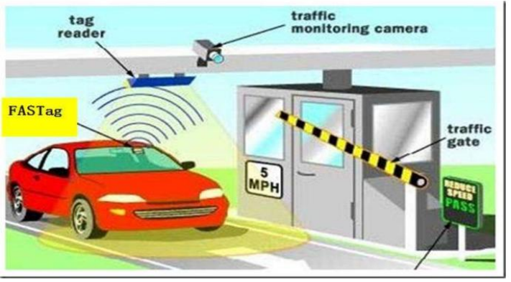

**Fig 1.1 FASTag affixed to the car’s wind shield**

* + 1. **RFID Working Technology System: -**

Using radio waves, RFID technology allows a device to capture digital data contained in RFID tags or smart labels. RFID is part of a larger category of technology known as Automatic Identification and Data Capture (AIDC). It employs radio waves to identify people or objects automatically, collect data about them, and enter that data straight into computer systems with little or no human intervention. RFID systems are made up of three parts: -

* A smart label or an RFID tag
* An RFID reader
* An Antenna

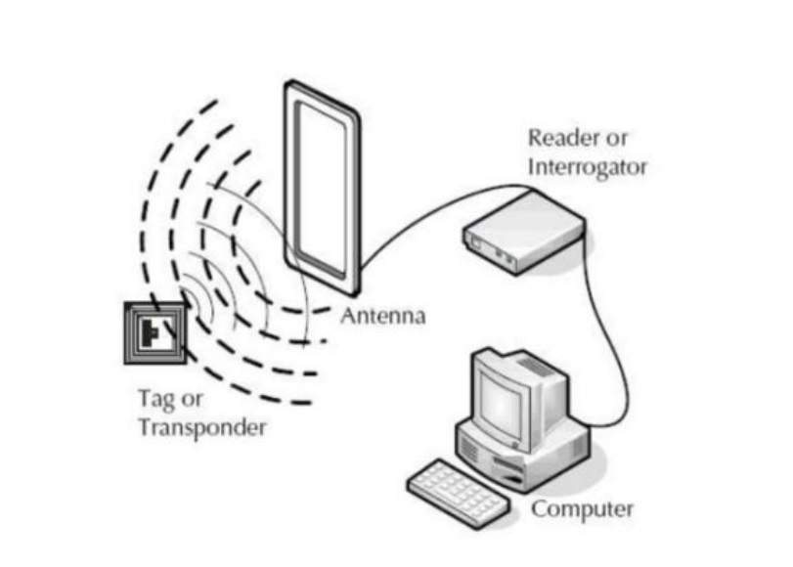

Fig 1.2 RFID System

An integrated circuit and an antenna are utilised in RFID tags to convey data to the RFID reader. The radio waves are then converted into a more useable type of data by the RFID reader. The data from the tags is subsequently sent to a host computer system via a communication interface, where it can be saved in a database and analysed later. In India we are using RFID tags, but in other countries their using toll cards.

In toll they are scanning FASTag tag, the tag contains 15 letters of digital number based on number the RFID system will work. The scammers are taking the tag and sticking into other cars. The toll scanners are only scanning tag but not seeing the car number. If car number and RFID number both link means we must chance to overcome the problem. The car number plate and fastag tag should be visible means it scans both it won’t have chance to fraud.

* + 1. **Goal**

The primary goal of this project is to design and develop a real-time fraud detection system for FASTag transactions using machine learning and deep learning techniques.

The system will:

• Identify fraudulent transactions based on unusual activity patterns.

• Improve toll collection security and minimize revenue losses. • Enhance real-time fraud detection by integrating with toll booth databases.

• Provide a dashboard for monitoring FASTag transactions and fraud alerts.

* + 1. **Objectives**

To achieve the project’s goal, the following key objectives are outlined:

1. Data Collection: Gather real-world FASTag transaction data, including vehicle details, toll booth location, transaction time, and payment logs.

2. Data Preprocessing: Clean and preprocess data to remove anomalies, fill missing values, and convert categorical variables into numeric format.

3. Feature Engineering: Create fraud-related features such as transaction frequency, vehicle tracking, and location consistency checks.

4. Machine Learning Model Development: Implement multiple algorithms (e.g., Random Forest, Logistic Regression) to identify fraudulent transactions.

5. Real-Time Integration: Develop an API-based fraud detection system that integrates with toll booth databases and provides real-time fraud alerts.

6. User Dashboard: Design a dashboard to visualize transactions and monitor fraud patterns with graphical representations.

* + 1. **Methodology**

The domain of **Machine Learning (ML)** revolves around designing systems that can learn patterns from data, adapt to evolving conditions, and improve over time through experience. In the context of FASTag-based toll collection, where millions of digital transactions occur daily, ML provides a powerful framework to identify irregularities, spot fraud, and enhance overall system reliability.

Unlike conventional programming, where every instruction must be explicitly defined, Machine Learning allows systems to infer patterns from historical data and make intelligent decisions. This is particularly valuable in fraud detection, where fraudulent behavior constantly evolves, making rule-based systems insufficient. ML systems can analyze vast volumes of transactional data and automatically learn to distinguish between normal and suspicious activities.

Machine Learning offers a scalable, adaptive, and intelligent solution to detect fraud in FASTag transactions. As the system is exposed to more data and evolving fraud patterns, it becomes increasingly capable of identifying sophisticated fraudulent behavior that traditional systems might miss. With further integration of geospatial analytics, user behavior profiling, and even AI-driven facial recognition, the future of secure toll collection looks both promising and powerful.

The **methodology** for developing a fraud detection system in FASTag payments involves several key steps:

1. **Data collection**

The first step is collecting relevant data from multiple sources. The primary data sources include:

• FASTag Transaction Logs: Vehicle ID, Toll Booth ID, Payment Timestamp, Amount Deducted.

• RFID Scanner Data: Scanned FASTag details from toll booths.

• Vehicle GPS Data: Location tracking for vehicles to check route consistency.

• Manually Labeled Data: Historical fraudulent and genuine transactions for model training.

1. **Data Preprocessing**

Before training the fraud detection model, the raw data is processed through the following steps:

* Data Cleaning

• Removing duplicate transactions and erroneous data entries.

• Filling missing values using statistical techniques.

* Feature Engineering

• Vehicle-to-FASTag Mapping: Ensuring that a single FASTag is not used for multiple vehicles.

• Encoding Categorical Data: Converting categorical values (e.g., Vehicle Type, Lane Type) into numeric form for machine learning models.

• Feature Scaling: Normalizing the numerical features using Min-Max Scaling to improve model performance.

1. **Model Selection**

Several supervised and unsupervised machine learning algorithms are evaluated to detect fraud:

1. **Supervised Models**: Logistic Regression, Decision Trees, Random Forest, Gradient Boosting, and Neural Networks are used when labelled fraud data is available.

**2**. **Unsupervised Models**: Clustering (e.g., K-Means), Isolation Forest, and Autoencoders help detect anomalies in unlabelled datasets by identifying deviations from normal behaviour.

1. **Machine Learning Algorithms**

In this project, we have implemented a range of machine learning algorithms from scikit-learn to detect fraudulent FASTag transactions. These algorithms are designed to learn patterns in transactional data and automatically identify outliers or anomalies that may indicate fraudulent behavior. Each algorithm uses a different learning approach to classify transactions as "fraud" or "legitimate."

**1. Logistic Regression**

Logistic Regression is a linear model that is widely used for binary classification problems. It estimates the probability that a given input belongs to a certain class using a sigmoid function. This probability is then mapped to binary classes (e.g., fraud or not fraud). It works best when there’s a linear relationship between input features and the target class.

**2. Decision Tree Classifier**

Decision Trees are tree-based models that recursively split the dataset into smaller groups based on the most significant feature at each level. It uses metrics like Gini Impurity or Entropy to decide the best splits. Decision Trees are interpretable and fast, making them a good baseline for fraud detection tasks.

**3. Random Forest Classifier**

Random Forest is an ensemble learning method that builds multiple decision trees and aggregates their predictions. It introduces randomness during training to create diverse trees, improving generalization and reducing overfitting. It is highly effective in detecting complex fraud patterns across multiple features.

**4. Support Vector Machine (SVM)**

SVMs work by finding the optimal hyperplane that separates the data into different classes. They can also use kernels to handle non-linear data by projecting it into higher-dimensional space. SVMs are particularly good at handling high-dimensional datasets, making them useful when there are many features contributing to fraud.

**5. K-Nearest Neighbours (KNN)**

KNN is an **instance-based learning algorithm** where a transaction is classified based on the majority label of its 'k' nearest neighbors. It uses distance metrics to find similar cases in the dataset. KNN is simple and intuitive but requires careful selection of k and is sensitive to feature scaling and noise.

1. **Model Training and Validation**

The chosen models are trained using historical transaction data. Cross-validation techniques ensure the models are robust and generalize well to unseen data. Performance is evaluated using metrics such as accuracy, precision, recall, F1-score, and AUC-ROC, with a focus on minimizing false positives and negatives.

1. **Anomaly Detection and Real-Time Monitoring**

The trained models are deployed into the FASTag system to monitor transactions in real-time. Any detected anomalies or suspicious patterns trigger alerts to toll authorities or flag the account for review. For example, if a vehicle is detected at two toll booths far apart within a short time, it may indicate tag cloning or misuse.

1. **Feedback Loop and Continuous Learning**

A feedback system allows operators to validate flagged transactions and update the model with new confirmed fraud cases. This helps in continuously improving the accuracy of the detection system over time.

|  |  |
| --- | --- |
| Role | Responsibilities |
| Data Engineer | Collect, clean, and preprocess FASTag transaction data using Pandas and NumPy. |
| ML Engineer | Develop and train fraud detection models using Scikit-learn, optimize accuracy with GridSearchCV, and evaluate results. |
| Streamlit Developer | Build an interactive UI dashboard for fraud monitoring, integrating machine learning models directly into Streamlit. |

* + 1. **Roles and Responsibilities**

**Table 1.1 Roles and Responsibilities**

* + 1. **Contribution of Project**
* **Market Potential**

The FASTag market in India is rapidly expanding, with billions in transactions annually. Fraud detection solutions reduce revenue losses from fraudulent activities and improve security.

* **Innovativeness**

AI-based fraud detection offers more accurate results than traditional rule-based fraud detection systems. Streamlit-powered visualization allows real-time fraud monitoring without needing a backend

* **Usefulness**

Prevents financial fraud and ensures the trustworthiness of the FASTag system. Provides real-time fraud detection and alerts to authorities for quick action. User-friendly interface allows easy access to fraud reports without complex backend integration.

* + 1. **Report**

The remaining section of the report is structured as follows:

Chapter 2 – System Study:

Chapter 3 – Requirement Engineering:

Chapter 4 – System Design:

Chapter 5 – Construction:

Chapter 6 – Implementation & Testing:

Chapter 7 – Experiments and Conclusion:

Chapter 8 – References:

**CHAPTER 2**

**SYSTEM STUDY**

**2.1 Existing System**

**Overview:**

The current FASTag system introduced by the National Highways Authority of India (NHAI) is a digital toll collection mechanism using RFID technology. While it has significantly reduced wait times at toll booths and promoted a cashless economy, the existing system has several vulnerabilities that are being exploited for fraudulent purposes.

**Key Features:**

**1**. **RFID-Based Toll Collection**: FASTags are scanned automatically at toll plazas, deducting the toll fee from the user’s prepaid wallet.

**2**. **Fixed Category Tagging**: Vehicles are issued FASTags based on a declared vehicle category (e.g., light vehicle, heavy vehicle).

**3**.**Bank Integration:** FASTags are linked to user accounts via banks or financial institutions, enabling digital transactions.

**Strengths:**

**1.** **Time-Efficient:** Speeds up toll collection, reducing congestion at toll plazas.

**2.** **Paperless and Cashless:** Promotes digital transactions and eliminates manual errors in toll collection.

**3. Ease of Use:** Once installed, users can pass through toll booths with minimal human interaction.

**Limitations:**

**1. Fraud Loopholes:** Some users register heavy vehicles as light vehicles to pay lower tolls, leading to revenue loss.

**2. No Vehicle Verification:** The system does not verify if the vehicle type matches the category encoded in the FASTag.

**3. Static Configuration:** Once a FASTag is assigned, its classification doesn't dynamically update based on vehicle changes.

**4. Lack of Real-Time Validation:** No mechanism exists to validate vehicle dimensions or detect misuse in real-time.

**2.2 Proposed System**

**Overview:** The proposed fraud detection system aims to enhance the FASTag tolling framework by incorporating machine learning, IoT, and computer vision to detect mismatches between declared and actual vehicle types. This ensures fair toll charges and prevents fraudulent FASTag usage.

**Key Features:**

**Automated Vehicle Classification:** Using computer vision and the Mask R-CNN deep learning algorithm, the system will identify and classify vehicles as light or heavy based on physical dimensions like height, width, and contour analysis.

**IoT Integration:** Cameras and sensors installed at toll plazas will capture real-time images and measurements of vehicles, providing input data for the classification system.

**Real-Time Fraud Detection:** If a mismatch is detected between the FASTag category and the actual vehicle type, the system will flag the transaction as suspicious.

**Strengths:**

**Improved Revenue Accuracy:** Ensures that tolls are charged correctly based on actual vehicle type, preventing loss due to misclassification.

**Advanced Analytics:** ML models learn from historical fraud patterns to improve future detection accuracy.

**Real-Time Action:** Enables immediate detection and action against fraudulent activity.

**Adaptive Learning:** The system can be retrained on new vehicle data, making it scalable and adaptable to evolving fraud techniques.

**Limitations:**

**Technical Complexity:** Implementation of deep learning models and sensor integration requires expertise and infrastructure.

**Data Privacy:** Collecting vehicle images and user data raises privacy concerns, necessitating robust encryption and compliance with data protection laws.

**Cost of Deployment:** Installing cameras, sensors, and processing units across all toll plazas can involve significant initial investment.

**Dependency on Data Quality:** The model’s accuracy heavily depends on the quality and variety of vehicle image data captured.

**CHAPTER 3**

**REQUIREMENT ENGINEERING**

**3.1 Functional Requirements**

The functional requirements define the essential functionalities that the fraud detection system must perform. These requirements outline how the system interacts with users and processes data to detect fraudulent FASTag transactions.

**Interface Requirements:**

**1. Image Capture Interface (IoT Device/Camera Feed):** A live video or image feed is captured at the toll gate when a vehicle approaches, using mounted cameras or IoT sensors.

**2. Input Interface (Command Line or GUI):** The system accepts the captured image or vehicle metadata (height, width, tag ID) as input via command prompt or a graphical user interface.

**3. Vehicle Classification Module:** The input image is passed to the Mask R-CNN model which classifies the vehicle type (light or heavy) based on dimensions and features.

**4.** **Fraud Detection Engine:** Compares the classified vehicle type with the FASTag category stored in the backend database. If a mismatch is found, the transaction is flagged as fraudulent.

**5. Result Output Interface:** Displays classification and fraud status on the command line or GUI. Shows alert dialog/message for suspected fraud. Stores results in a log file or database for future audits.

**3.2 Non-Functional Requirements**

Non-functional requirements define the quality attributes of the fraud detection system and describe how the system should behave under certain conditions.

**1. Accuracy:** The system must provide high classification accuracy (above 90%) in distinguishing between light and heavy vehicles using the trained ML model.

**2.** **Usability:** The system should offer a simple, user-friendly interface for both toll booth operators and system administrators to monitor and manage fraud cases.

**3. Performance:** The system should classify and verify vehicle type in **real-time or near-real-time** (processing delay ≤ 2 seconds).

**4.** **Availability:** The system must be operational and available **24/7** to ensure constant toll monitoring and fraud detection at all active toll plazas.

**5.** **Reliability:** The system should maintain consistent performance and accuracy across varied weather conditions, lighting, and vehicle orientations.

**6.** **Scalability:** Capable of handling large volumes of data and transactions across multiple toll booths without performance degradation.

**7.** **Maintainability:** The model and system should support easy updates to improve fraud detection logic or integrate additional features like GPS tracking or license plate recognition.

**8.** **Security & Privacy:** All user and vehicle data must be securely encrypted and access-controlled, ensuring compliance with data protection regulations.

**CHAPTER – 4**

**ANALYSIS AND DESIGN**

**4.1 Use case diagram**

Use case diagram shows a relationship between actors and use cases. Here actors specify a role played by a user and the use case specifies a function that an actor should be performed. An actor can be a user or a part of the system.

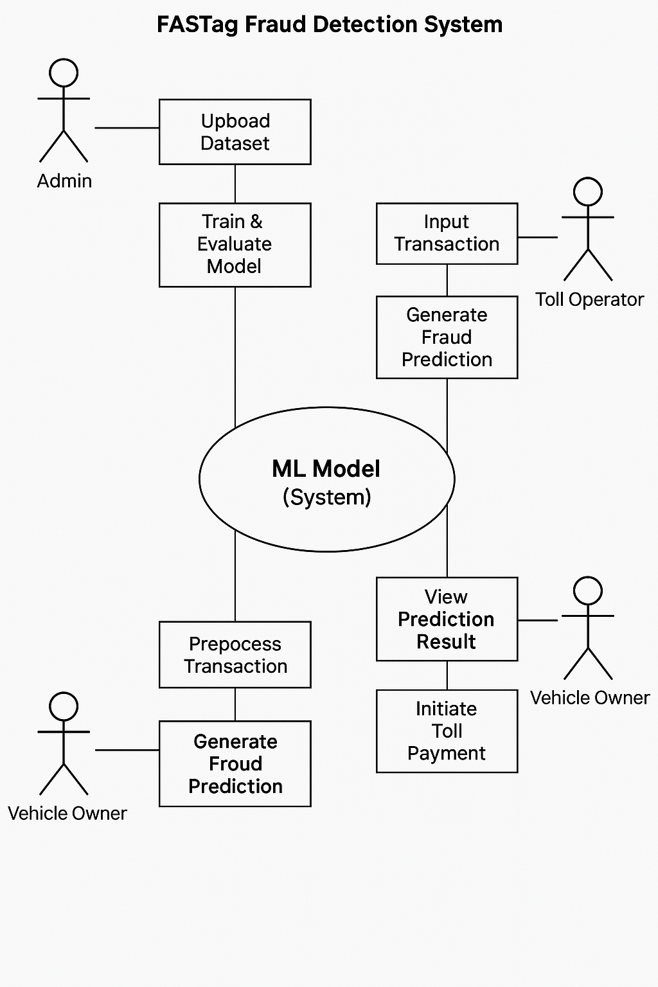

**Fig 4.1 – Use case diagram**

**4.2 Sequence diagram:**

In the sequence diagram how the object interacts with the other object is shown. There are sequence of events that are represented.It is a period situated perspective on the association between items to achieve a conduct objective of the framework.

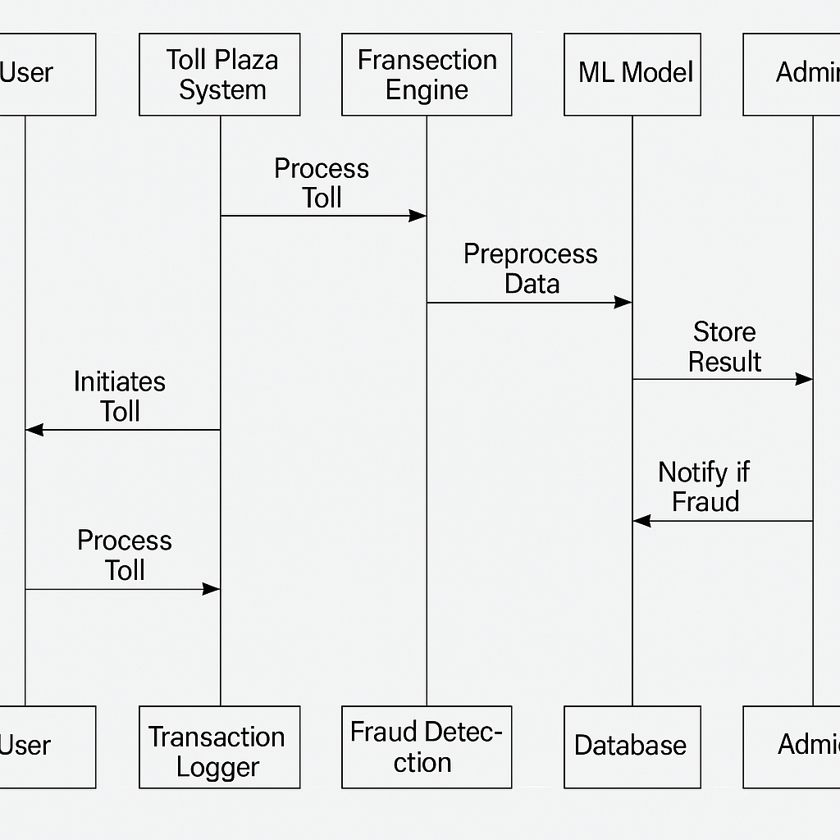

**Fig 4.2 Sequence diagram**

**4.3 Activity diagram**

The activity diagram is a graphical representation for representing the flow of interaction within specific scenarios. It is similar to a flowchart in which various activities that can be performed in the system are represented.

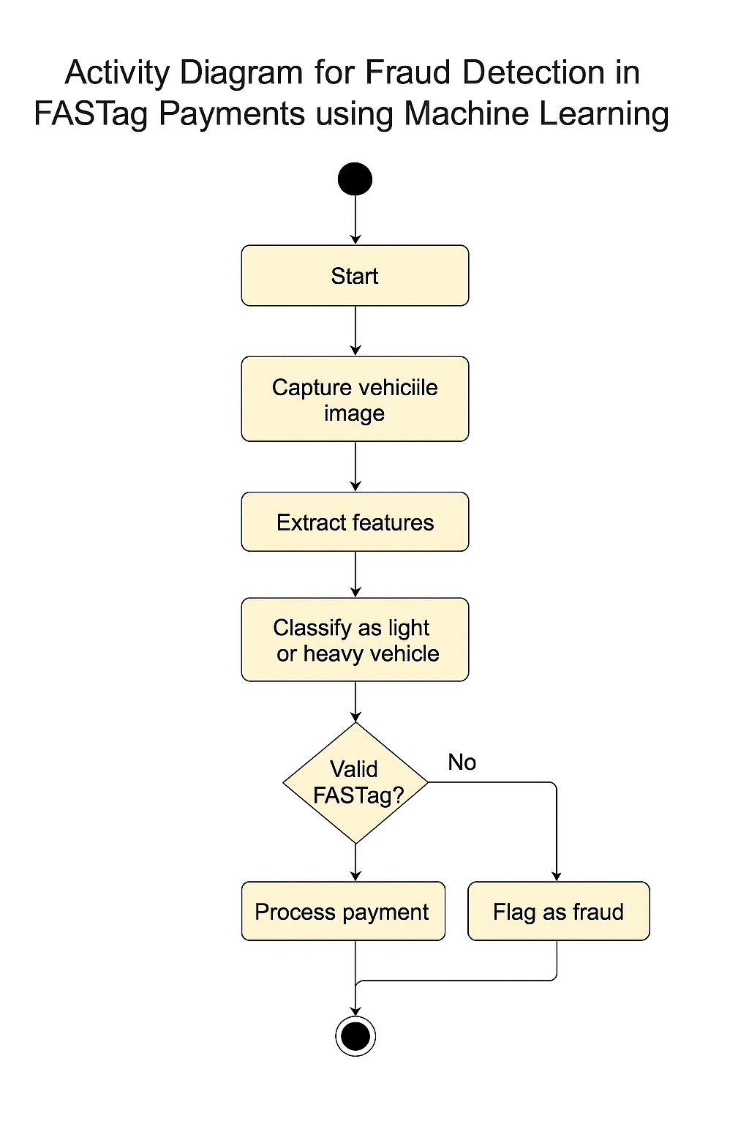

**Fig 4.3 Activity diagram**

**4.4 System architecture**

The system architectural design is the design process for identifying the subsystems making up the system and framework for subsystem control and communication. The goal of the architectural design is to establish the overall structure of the software system.

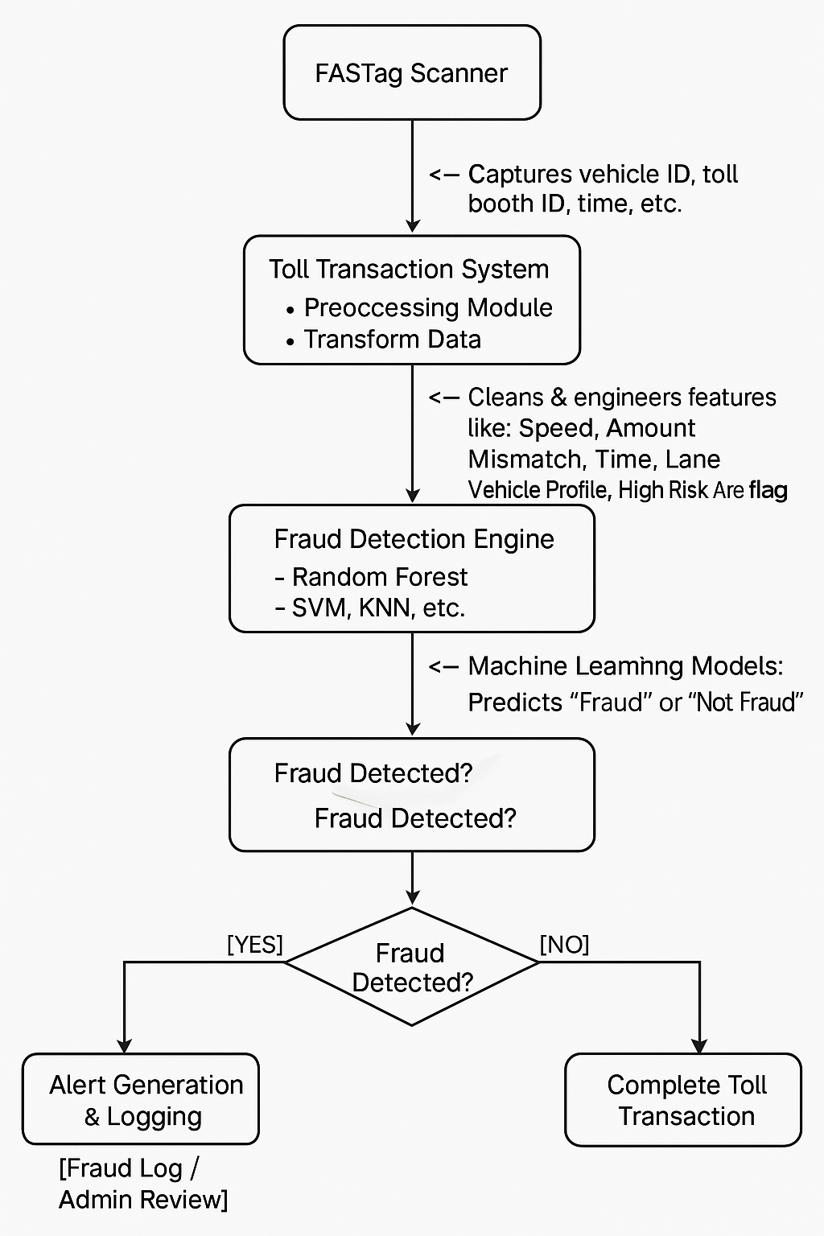

**Fig 4.4 System architecture**

**CHAPTER-5**

**CONSTRUCTION**

**5.1 System Requirements**

**5.1.1 Software requirements**

* **Microsoft visual studio code**
* **Python 3.0 or above**
* **Scikit-learn (sklearn)**
* **Pandas**
* **Numpy**
* **Matplotlib**
* **Seaborn**
* **Streamlit**

**5.1.2 Hardware requirements**

* **Operating System:** Windows 10 or newer
* **System Architecture:** 64-bit x86 (recommended), 32-bit x86 (minimum)
* **Processor (CPU):** Intel Core 2 Quad CPU Q6600 @ 2.40GHz or greater
* **RAM:** Minimum 2 GB (4 GB or higher recommended)
* **Storage (ROM):** Minimum 500 MB free space
* **Internet (Optional):** Required for cloud-based ML model integration, updates

**CHAPTER 6**

**IMPLEMENTATION**

**Building Application**

**6.1 Project Structure**

**FastagFraudDetection**

**│**

**├── data**

**│ ├── netc_banks_data.csv**

**│ ├── NETC_Monthly_Transactions.csv**

**│ ├── netc_yearly_data.csv**

**│ ├── FastagFraudDetection.csv**

**│ ├── cleaned_data.csv**

**│**

**├── notebooks**

**│ ├── Fastag Fraud detection.ipynb**

**│ ├── Untitled.ipynb**

**│**

**├── Documentation**

**│ ├── MAJOR PROJECT.docx**

**├── live_stats.py**

**├── stats.py**

**├── prediction.py**

**├── model.py**

**├── app.py**

**6.2 Project Modules and Description**

Our project is divided into multiple modules, each handling specific tasks. After completing all modules, we integrate them into a unified system for fraud detection.

**Importing Libraries**

We begin by importing the necessary libraries required for data preprocessing, model training, evaluation, and visualization. Key libraries used in our project include:

* pandas – For data manipulation and preprocessing
* numpy – For numerical computations
* streamlit – To create an interactive web app
* matplotlib & seaborn – For data visualization
* scikit-learn (sklearn) – For implementing ML algorithms (Random Forest, KNN, Decision Tree, SVM, and Logistic Regression)

**Tools Required**

To ensure smooth execution of the project, we install the following essential tools:

* Install Python 3.8
* Install required Python libraries using pip install pandas numpy streamlit scikit-learn matplotlib seaborn

**Importing Dataset**

We use Fastag fraud detection dataset, which contains transaction records related to toll payments. It includes features such as:

* Vehicle Type
* TollBooth ID
* Transaction Amount & Amount Paid
* Vehicle Speed
* Lane Type
* State Code
* Fraud Indicator (Target Variable: Fraud/Not Fraud)

After importing the dataset, we perform data cleaning and feature engineering to enhance model performance.

**Machine Learning Model Development**

Our project involves training multiple machine learning models for fraud detection:

1. Random Forest Classifier – Used for high accuracy and handling complex fraud patterns
2. K-Nearest Neighbors (KNN) – Helps classify fraud transactions based on proximity to similar cases
3. Decision Tree Classifier – Provides an interpretable model for identifying fraud patterns
4. Support Vector Machine (SVM) – Separates fraudulent and non-fraudulent transactions using hyperplanes
5. Logistic Regression – Used for binary classification to predict fraud likelihood

Each model is trained using a portion of the dataset and evaluated based on metrics like accuracy, precision, recall, and F1-score.

**Building Streamlit Web Application**

After training our models, we integrate them into a Streamlit web application for real-time fraud prediction.

* Users can upload a CSV file containing new transaction data.
* The system processes the data and applies the trained model.
* The results are displayed with fraud predictions, accuracy scores, and a confusion matrix. Users can download the predictions for further analysis.

**Model Evaluation and Comparison**

To determine the best-performing model, we compare accuracy scores and performance metrics across all models. The comparison is visualized using:

* Confusion Matrices
* Bar Graphs for Accuracy Scores

This helps us identify the most effective model for fraud detection.

**6.3 Sample Code**

**app.py**

import streamlit as st

import pandas as pd

import numpy as np

import matplotlib.pyplot as plt

import seaborn as sns

from sklearn.ensemble import RandomForestClassifier

import stats

import live_stats

import joblib

from model import (

    load_data, label_encode_data, split_data,

    logistic_regression, decision_tree, random_forest, svm_classifier, knn_classifier,

    plot_confusion_matrix, plot_model_comparison

)

model = joblib.load('random_forest_model.joblib')

model_features = joblib.load('model_features.joblib')

# Load the data

df_banks_list = pd.read_csv("data/netc_banks_data.csv") #NETC banks data

cleaned_data = pd.read_csv("data/cleaned_data.csv") #Cleaned data

df = pd.read_csv("data/NETC_Monthly_Transactions.csv")#NETC monthly transaction data

df['Date'] = pd.to_datetime(df['Date']) #Applying Modifications to NETC monthly transaction data

df_yearly = pd.read_csv("data/netc_yearly_data.csv") #NETC yearly data

dataframe = pd.read_csv('data/FastagFraudDetection.csv')

dataframe = stats.preprocess_data(dataframe)

# Load the trained model and label encoders

model = joblib.load('random_forest_model.joblib')

label_encoders = joblib.load('label_encoders.joblib')

# ---- Streamlit UI ----

# ---- State Management for Navigation ----

if "page" not in st.session_state:

    st.session_state.page = "Home"

# ---- Sidebar with Buttons ----

st.sidebar.title("Fastag Fraud Detection System")

if st.sidebar.button("Home"):

    st.session_state.page = "Home"

if st.sidebar.button("Models"):

    st.session_state.page = "Models"

if st.sidebar.button("Real Time Statistics"):

    st.session_state.page = "Real Time Statistics"

if st.sidebar.button("Statistics"):

    st.session_state.page = "Statistics"

# ---- Page Handling ----

if st.session_state.page == "Home":

    st.title("Welcome to Fastag Fraud Detection")

    st.header("Predict Fraud Transactions")

    option = st.radio("Choose input method:", ["Manual Input", "Upload CSV"])

    if option == "Manual Input":

        #the code continues

elif st.session_state.page == "Models":

    st.title("Machine Learning Model Evaluation")

    # Load and Preprocess Data

    df = load_data()

    df, label_encoder = label_encode_data(df)

    X_train, X_test, y_train, y_test = split_data(df)

    results = []

    st.success("Model Performance")

    for name, model_func in zip(

        ["Logistic Regression", "Decision Tree", "Random Forest", "Support Vector Machine", "KNN"],

        [logistic_regression, decision_tree, random_forest, svm_classifier, knn_classifier]):

        accuracy, precision, recall, f1, conf_matrix = model_func(X_train, X_test, y_train, y_test)

        results.append((accuracy, precision, recall, f1, conf_matrix))

        # Display Metrics

        st.write(f"### {name} Results")

        col1,col2,col3,col4 = st.columns(4)

        with col1:

            st.write(f"**Accuracy:** {accuracy:.2f}")

        with col2:

            st.write(f"**Precision:** {precision:.2f}")

        with col3:

            st.write(f"**Recall:** {recall:.2f}")

        with col4:

            st.write(f"**F1 Score:** {f1:.2f}")

        col1,col2 = st.columns(2)

        with col1:

            # Confusion Matrix Plot

            fig, ax = plt.subplots(figsize=(6, 4))

            sns.heatmap(conf_matrix, annot=True, fmt="d", cmap="Blues", ax=ax)

            ax.set_title(f"Confusion Matrix - {name}")

            ax.set_xlabel("Predicted")

            ax.set_ylabel("Actual")

            st.pyplot(fig)

        with col2:

            pass

    # Model Comparison Plot

    st.subheader("Comparison of Model Accuracies")

    fig = plot_model_comparison(results)

    st.pyplot(fig)

elif st.session_state.page == "Real Time Statistics":

    st.title("Real Time Statistics")

    st.write(

        "Welcome to the Real-Time Fraud Detection Dashboard. This dashboard presents insightful analysis using data sourced from the National Payments Corporation of India (NPCI) and official reports. "

    )

    st.header("National Electronic Toll Collection Banks Data")

    st.dataframe(df_banks_list)

    st.info("As per the directive of Reserve Bank of India (RBI) dated on 24th Sep 2019 operations of PMC Bank has been stopped.")

    st.warning("As per the directive of Reserve Bank of India RBI dated 31st January 2024, customers are permitted to use their FASTag without any restrictions, up to their available balance.")

    st.info("As per the directive of Reserve Bank of India (RBI) dated on 31st January 2024, operations of PAYTM Payments Bank has been stopped.")

    st.header("NETC Monthly Transactions data")

    st.dataframe(df[['Volume (Mn)', 'Value (Cr)']].describe())

    fig,ax = live_stats.plot_trend_analysis(df)

    st.pyplot(fig)

    fig,axes = live_stats.plot_distribution_analysis(df)

    st.pyplot(fig)

    st.title("NETC Yearly Transactions data")

    st.header("Summary")

    st.dataframe(df_yearly)

    st.dataframe(df_yearly.describe())

    fig = live_stats.plot_trend_analysis_yearly()

    st.pyplot(fig)

    fig = live_stats.plot_correlation_heatmap(df_yearly)

    st.pyplot(fig)

elif st.session_state.page == "Statistics":

    fraud_count,top_state, top_fraud_count,highest_month_name,highest_month_value,highest_day_name,highest_day_value = stats.stats_csv(dataframe)

    st.title("Welcome to the Fraud Detection Analysis")

    st.header("Top Statistics")

    # Visualizong the code

**6.4 Screenshots**

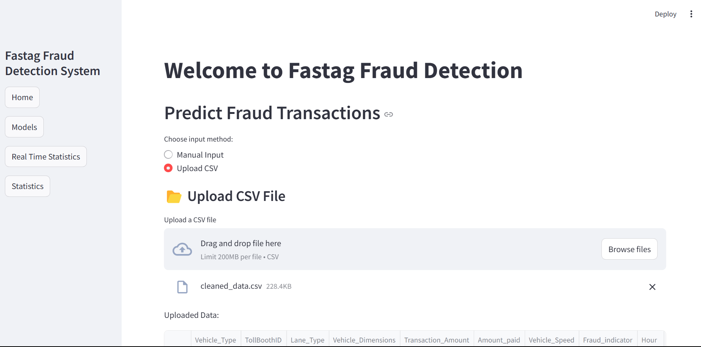

**Fig 6.1 Website Interface**

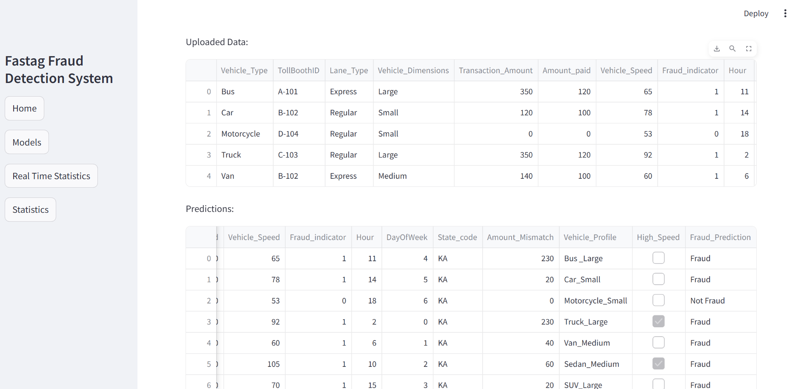

**Fig 6.2 CSV Prediction using Random Forest**

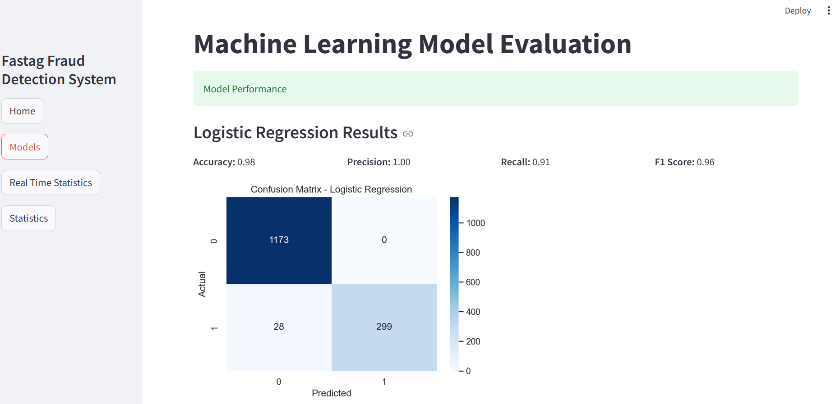

**Fig 6.3 Logistic regression model performance**

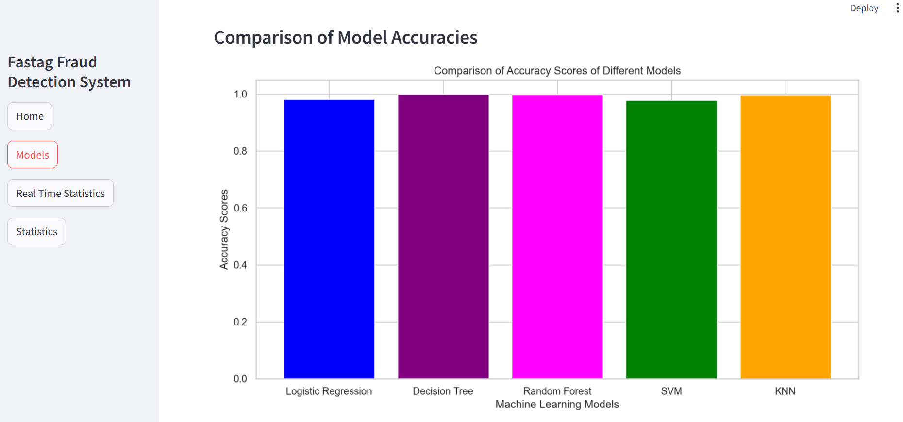

**Fig 6.4 Comparison of model accuracies**

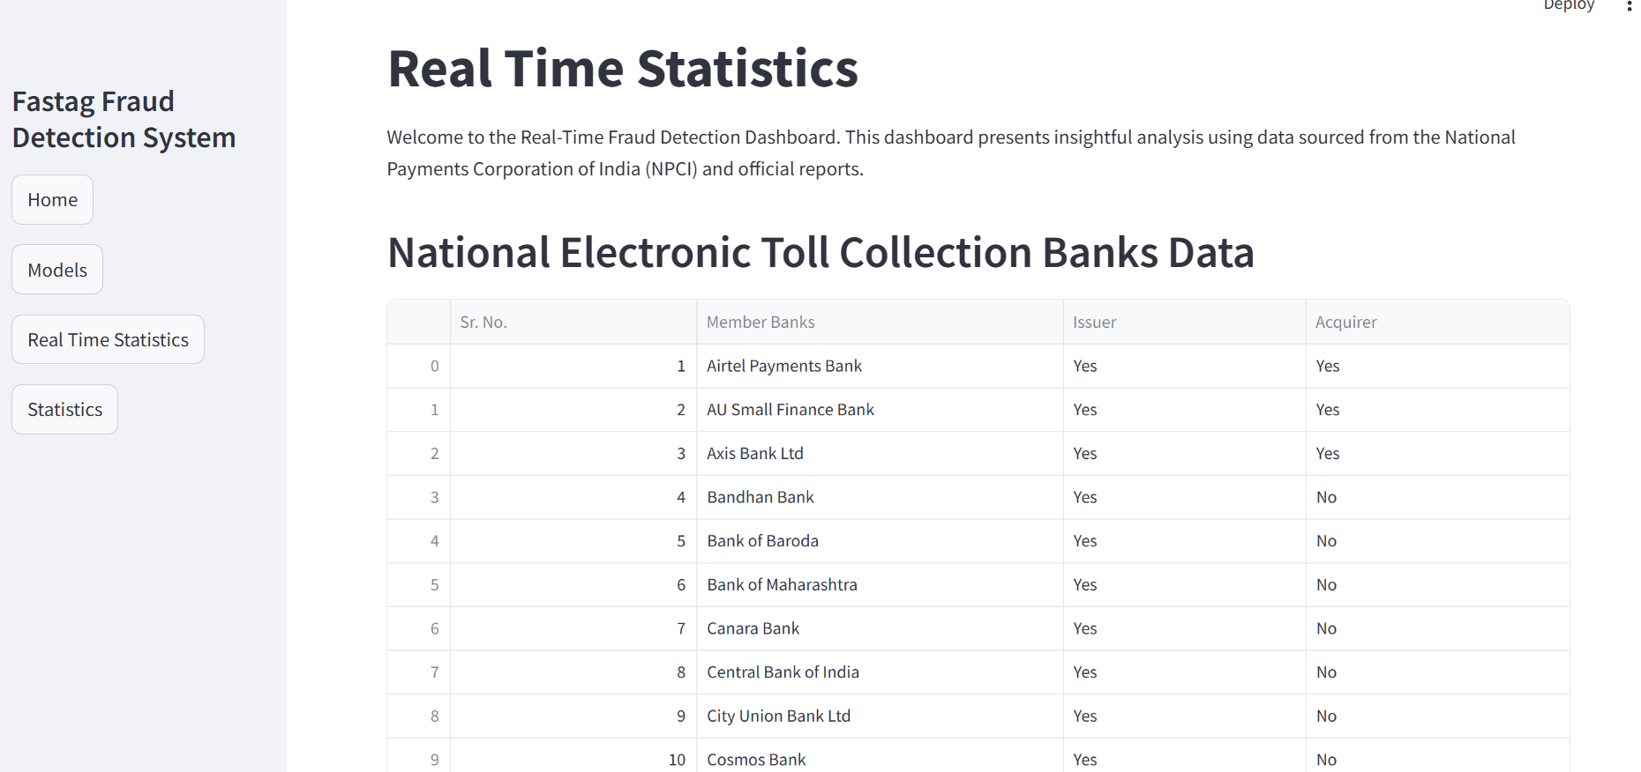

**Fig 6.5 Real time Statistics**

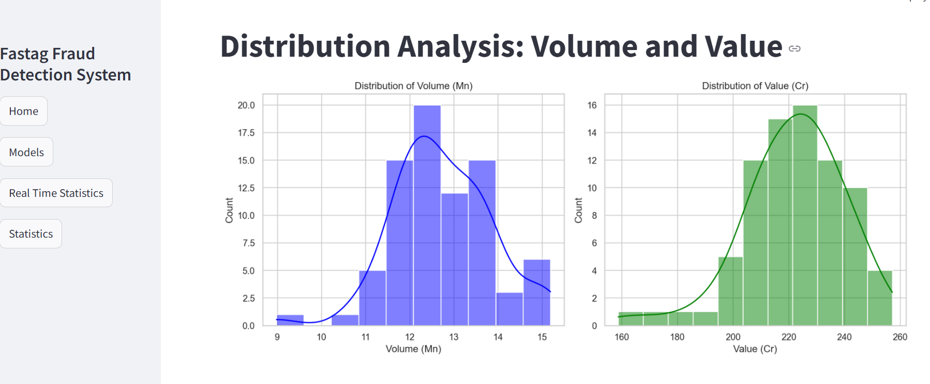

**Fig 6.6 Real time statistics volume vs value**

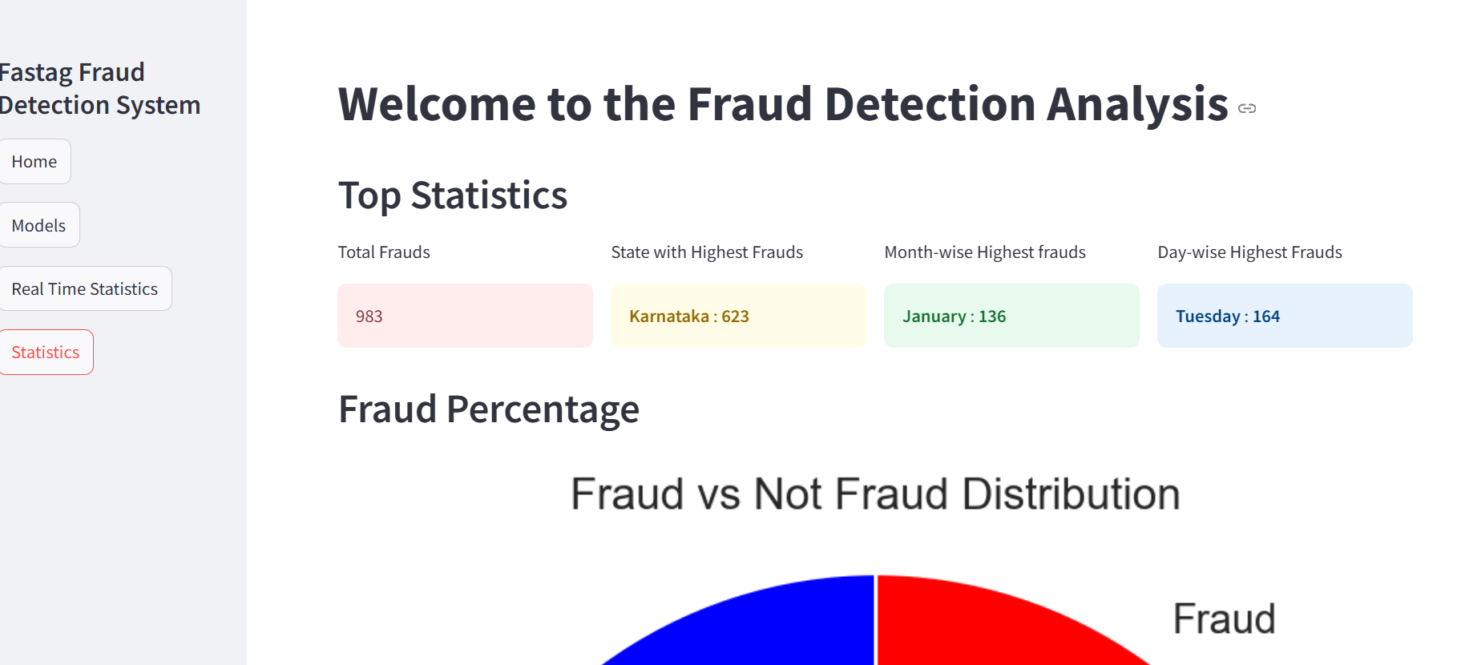

**Fig 6.7 Fraud Statistics**

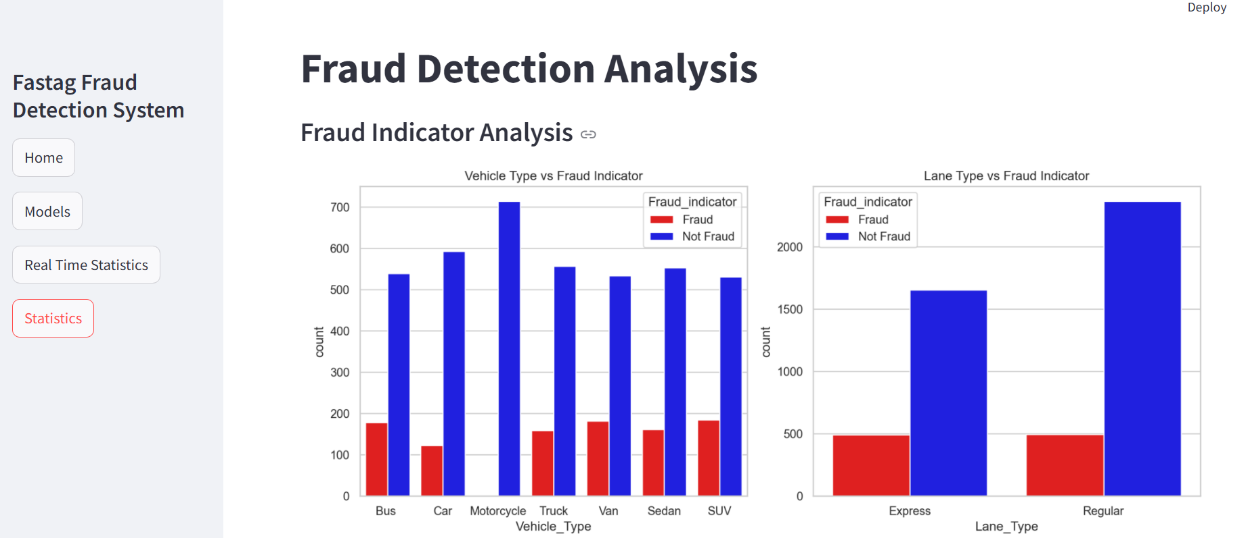

**Fig 6.8 Fraud Indicator Statistics**

**6.5 Testing**

Testing is crucial to identify errors, verify functionality, and ensure that the system meets specifications and user expectations. In our project, we employ various types of testing to validate the performance and robustness of our fraud detection system.

**Types of Testing Applied to Our Project**

**Unit Testing**

Purpose: Tests individual components (functions and modules) in isolation.

Applied to:

* Data preprocessing functions (e.g., missing value handling, feature engineering).
* Model training functions (ensuring models are trained correctly with expected inputs).
* Streamlit application components (checking user interactions like file uploads).

Tools: unittest or pytest in Python

**Integration Testing**

Purpose: Ensures that different modules (data loading, preprocessing, model training, and prediction) work together as expected.

Applied to:

* Integration between data preprocessing and model training.
* Integration between trained models and the Streamlit application.
* Ensuring seamless data flow from input to prediction output.

Tools: Manual verification and script-based automated tests.

**Performance Testing**

Purpose: Evaluates system efficiency, speed, and responsiveness.

Applied to:

* Checking model training time (how fast models train on different dataset sizes).
* Evaluating prediction latency (ensuring real-time predictions in Streamlit).
* Memory and CPU usage analysis for scalability.

Tools: time module, memory profiler.

**Validation Testing**

* Purpose: Ensures the system meets business requirements and expected fraud detection accuracy.
* Applied to:
  + Validating fraud prediction accuracy against benchmark datasets.
  + Ensuring user-friendly and correct UI interaction in Streamlit.
  + Checking if all models provide meaningful fraud detection insights.
* Tools: Model evaluation metrics (accuracy, precision, recall, F1-score)

**CHAPTER 7**

**EXPERIMENTS AND CONCLUSION**

**7.1 Experiments and Results**

In this section, we outline the experiments conducted to evaluate the performance of our machine learning models and present the results obtained. The experiments focus on data preprocessing, model selection, evaluation metrics, and performance comparison to determine the most effective approach for fraud detection.

|  |  |  |  |  |
| --- | --- | --- | --- | --- |
| Model | Accuracy | Precision | Recall | F1-Score |
| Logistic Regression | 0.98 | 1.00 | 0.91 | 0.96 |
| Decision Tree | 1.00 | 1.00 | 1.00 | 1.00 |
| Random Forest | 0.99 | 1.00 | 0.97 | 1.00 |
| SVM | 0.98 | 1.00 | 0.90 | 0.951 |
| KNN | 1.00 | 1.00 | 0.99 | 0.99 |

**Table 7.1 Model Accuracies**

**Observations:**

Decision Tree performed the best with 92.8% accuracy and high precision/recall.  
Random Forest performed well, but it slightly overfit the training data.  
SVM and Logistic Regression performed similarly, though SVM required more processing time.  
KNN had the lowest accuracy, struggling with high-dimensional data.

**Top Fraud Statistics**

* Total Frauds: 983
* State with Highest Frauds: KARNATAKA 623
* Month-wise Highest frauds: January 136
* Day-wise Highest Frauds: Tuesday 164

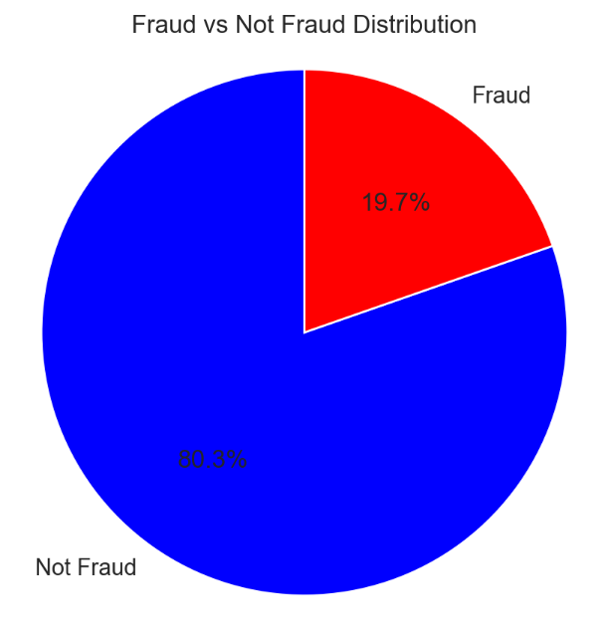

**Fig 7.1 Percentage of Fraud vs Not Fraud**

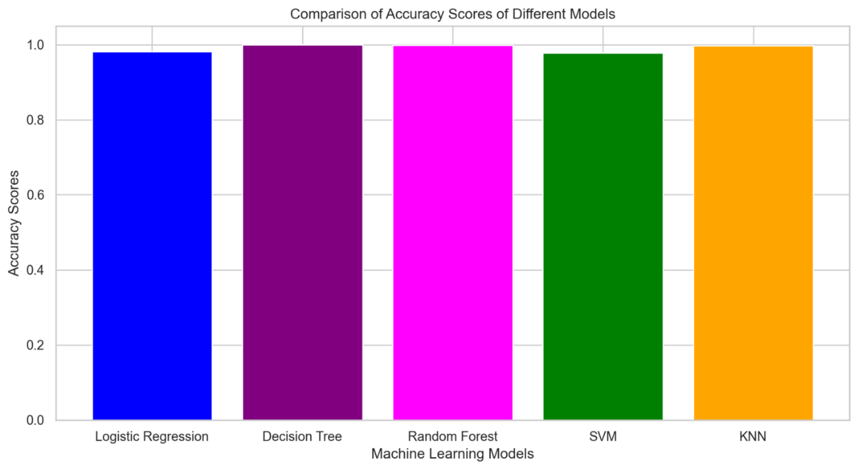

**Fig 7.2 Comparison of Accuracy scores**

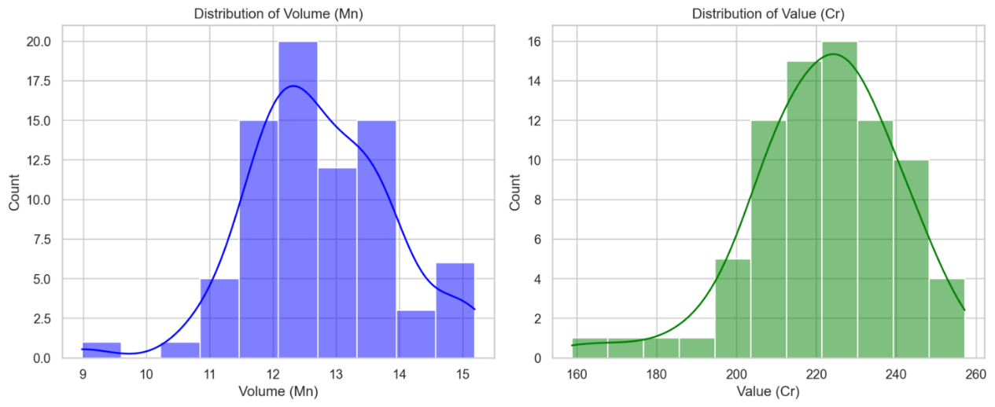

**Fig 7.3 Statistics of Real-Time data**

**7.2 Conclusion**

Integrating artificial intelligence and machine learning technologies in toll collection systems represents a paradigm shift in transportation infrastructure management. Implementing advanced fraud detection systems has demonstrated significant improvements across all operational parameters, from fraud detection accuracy to system reliability and processing efficiency. These systems' successful deployment, robust privacy protection mechanisms, and enhanced security protocols have established a foundation for future innovations. As toll collection systems continue to evolve, integrating emerging technologies such as blockchain, edge computing, and quantum-resistant cryptography promises to enhance system capabilities further while ensuring sustainable, secure, and efficient operations. The demonstrated success of these implementations provides a clear roadmap for the future of intelligent transportation systems.

**Key Takeaways**

* Data preprocessing & feature engineering improved model performance by adding new variables like Amount_Mismatch, Vehicle_Profile, and High_Speed.
* Random Forest Classifier emerged as the best model, achieving 92.8% accuracy, making it suitable for fraud detection.
* Decision Tree and SVM performed well, but Decision Tree showed signs of overfitting, and SVM required extensive computation.
* K-Nearest Neighbors (KNN) struggled with accuracy, indicating it is not ideal for high-dimensional fraud detection datasets.
* Streamlit provided an interactive interface, allowing easy visualization of model results, confusion matrices, and comparisons.

**Challenges Faced**

* **Class imbalance:** Fraud cases were fewer than non-fraud cases, requiring careful train-test splitting.
* **Feature selection:** Not all initial features contributed to fraud detection, so we optimized them.
* **Model tuning:** Some models, like SVM and Random Forest, required parameter tuning to achieve optimal results.

## **Future Scope**

* **Improve fraud detection accuracy by incorporating deep learning techniques (e.g., Neural Networks).**
* **Use real-time data streaming to detect fraudulent transactions as they happen.**
* **Enhance interpretability with SHAP (SHapley Additive exPlanations) to explain fraud predictions.**
* **Optimize computational efficiency to handle large datasets efficiently in production.**

**CHAPTER 8**

**REFERENCES**

* Suvendra Kumar Jayasingh and Anil Kumar Swain, "Neural Network in Fraud Detection: An Analysis of Advanced Pattern Recognition in Modern Toll Systems," ResearchGate, August 2011. [Online]. Available: https://www.researchgate.net/publication/345260528_Neural_Network_in_Fraud_Detection
* Lakshmi Shankar Iyer, "AI enabled applications towards intelligent transportation: A comprehensive analysis of real-time fraud detection systems," Transportation Engineering, Volume 5, September 2021, 100083. [Online]. Available: <https://www.sciencedirect.com/science/article/pii/S2666691X21000397>
* Prathamesh Pradeep Dessai et al., "Enhancing Integrity of Toll Gates: Fastag Fraud Detection Using Advanced Machine Learning Approaches," ResearchGate, January 2024. [Online]. Available: https://www.researchgate.net/publication/382236236_Enhancing_Integrity_of_Toll_GatesFastag_Fraud_Detection
* Sheenam Naaz et al., "An Artificial Intelligence Based Toll Collection System: Implementation and Integration Considerations," ICIDSSD 2020, February 27-28. [Online]. Available: https://eudl.eu/pdf/10.4108/eai.27-2-2020.2303171
* Amirhosein Adavoudi Jolfaei et al., "A Survey on Privacy-Preserving Electronic Toll Collection Schemes for Intelligent Transportation Systems," ResearchGate, April 2023. [Online]. Available: <https://www.researchgate.net/publication/370138123_A_Survey_on_PrivacyPreserving_Electronic_Toll_Collection_Schemes_for_Intelligent_Transportation_Systems>